ROLL IT UP SUSHI MENU
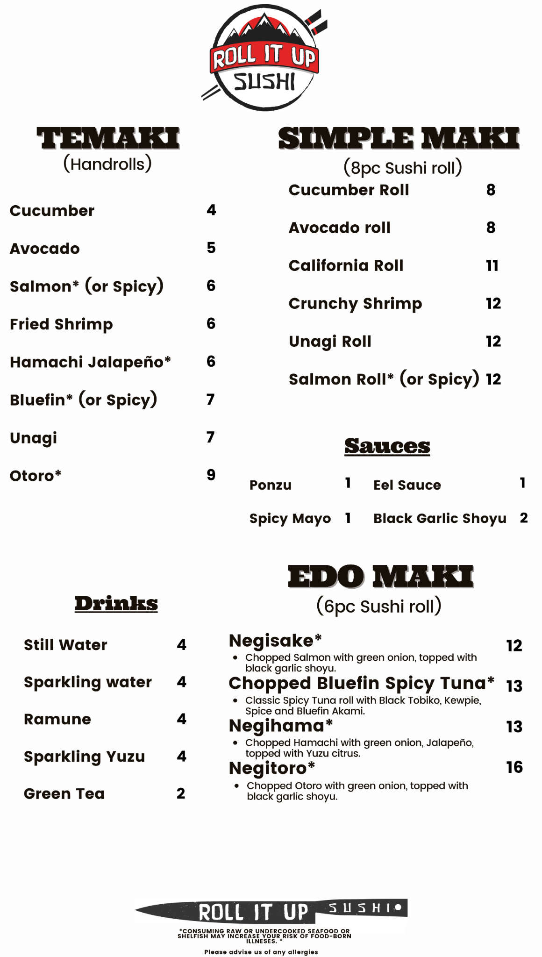

TEMAKI (Handrolls)
Cucumber ........ $4
Avocado ........ $5
Salmon* (or Spicy) ........ $6
Fried Shrimp ........ $6
Hamachi Jalapeño* ........ $6
Bluefin* (or Spicy) ........ $7
Unagi ........ $7
Otoro* ........ $9

SIMPLE MAKI (8pc Sushi Roll)
Cucumber Roll ........ $8
Avocado Roll ........ $8
California Roll ........ $11
Crunchy Shrimp ........ $12
Unagi Roll ........ $12
Salmon Roll* (or Spicy) ........ $12

SAUCES
Ponzu ........ $1
Spicy Mayo ........ $1
Eel Sauce ........ $1
Black Garlic Shoyu ........ $2

EDO MAKI (6pc Sushi Roll)
Negisake* ........ $12
Chopped Salmon with green onion, topped with black garlic shoyu.
Chopped Bluefin Spicy Tuna* ........ $13
Classic spicy tuna roll with black tobiko, kewpie, spice and bluefin akami.
Negihama* ........ $13
Chopped Hamachi with green onion, jalapeño, topped with yuzu citrus.
Negitoro* ........ $16
Chopped Otoro with green onion, topped with black garlic shoyu.

DRINKS
Still Water ........ $4
Sparkling Water ........ $4
Ramune ........ $4
Sparkling Yuzu ........ $4
Green Tea ........ $2

